# ASD Virtual Program Enrollment Guide

# ASD Virtual Polokalame Lesitala Ta’iala

Guidance for parents/guardians to enroll their student(s) in ASD Virtual Program via ParentConnect

Ta’iala mo matua/ma aiaga e lesitala ai latou fanau i le ASD Virtual Program (Polokalame) via “ParentConnect”

## Step-by-step guide

## Ta’iala i la’asaga i lea la’asaga

Log in to [ParentConnect](http://parentconnect.asdk12.org/) ([parentconnect.asdk12.org](http://parentconnect.asdk12.org/))

Log in to ParentConnect (parentconnect.asdk12.org)

* If ParentConnect PIN or password is not known, please visit [this website](https://parentconnect.asdk12.org/Production/ParentPortal/Home/LoginReminder) to reset password.  Resetting the password will also provide the PIN number in addition to the reset password to the email address on file.
* Afai e le iloa le ParentConnet PIN or password, fa’amolemole e asiasi le website e toe setiina ai le password. A toe setiina le password, o le a tu’uina atu ai fo’i ma le PIN numera e riseti ai le password o lo’o i le emeli i totonu o le faila.
* For additional assistance logging into ParentConnect, please create a support ticket via the ASD Parent/Student Support Portal at [help.asdk12.org](http://help.asdk12.org), or by calling 907-742-HELP.
* Mo se fesoasoani atili i totonu o le ParentConnect, fa’amolemole ia faia se ticket fesoasoani mai i le ASD Paren/Student Support Portal at help.asdk12.org, po’o le valauina le numera 907-742-HELP.

After successfully logging into ParentConnect, click **My Information** at the top of the screen.

Afai ua mae’a ma lelei le logging i totonu o le ParentConnect, kiliki My Information i luga o le screen.

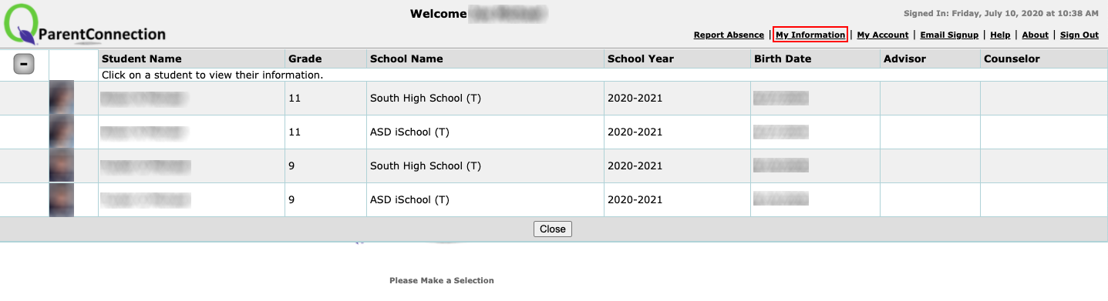

On the line showing the name of the student you wish to enroll in the ASD Virtual Program, click **Edit**.

I luga o le laina o lo’o fa’aali ai le igoa o lou alo o lo’o e mana’o e lesitala i le ASD Virtual Program (Polokalame), kiliki le Edit.

On the left side of the screen, click **Enroll In Virtual Program**.

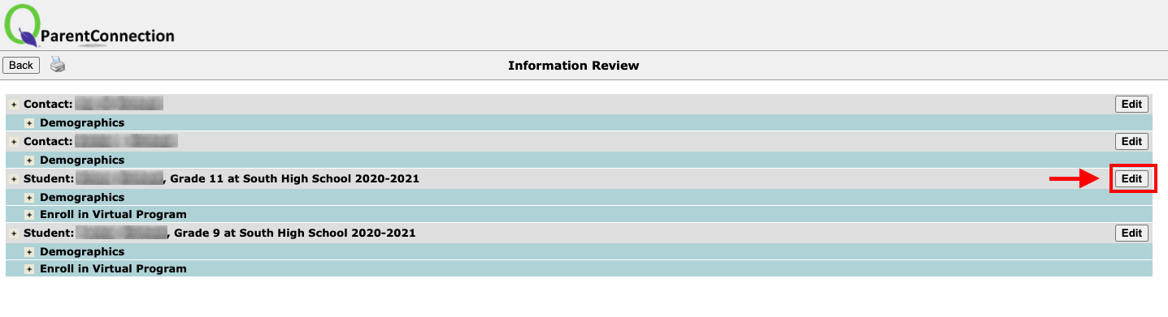

I le itu agavale o le screen, kiliki Enroll in Virtual Program (Polokalame)

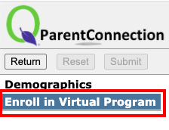

Review the information presented, then click on the **Check Box** to indicate that you want this student to be enrolled in the full time ASD Virtual Program.

Iloilo fa’amatalaga fa’alia, ona kiliki lea o le pusa (Check Box) e fa’aali ai e te mana’o ai e lesitala lou alo i le taimi atoa o le ASD Virtual Program (Polokalame).

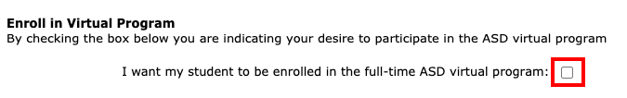

In the sections for **Student Device**, **Home Connectivity**, and **Other Program Participation**, select a response from the drop-down

I le vaega o le Student Device, Home Connectivity, ma Other Program Participation, filifili se tali mai le drop-down.

options.

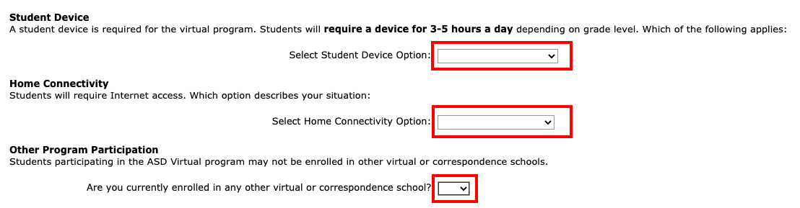

After completing all of the sections, click **Submit** at the top of the screen.  **Note:** You must **click Submit** for your responses to be saved.

A mae’a vaega uma, kiliki Submit o lo’o i luga o le screen. Fa’aliga: E ao ona e kiliki le Submit (Click Submit) mo au tali ina ia sefeina.

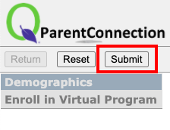

Clicking Submit will return you to the **My Information** screen.  If you have additional students to enroll in the ASD Virtual Program, repeat steps 3-7 for each student.

Kiliki Submit o le a toe fo’i ai o’e i le My Information screen. Afai e iai isi alo e lesitala i le ASD Virtual Program (Polokalame), toe fai le sitepu 3-7 mo isi alo.